JJ’s Computer Solutions – Small VM Network Lab Manual
Prepared by: Marc-Anthony Jones, CISO & Network Architect
Date: March 2025

Table of Contents
- Introduction
- Lab Overview & Purpose
- Goals of the Lab Setup
- Hardware & Software Components
- Static IP Assignments & Packet Tracer Design
- Windows Server 2025 Setup
- pfSense Firewall Configuration
- Linux (Ubuntu & Kali) Configuration
- Penetration Testing Procedures & Results
- Security Policy Highlights
- Observations, Lessons, and Next Steps
- Appendices

1. Introduction
This manual documents the design, configuration, testing, and security procedures of the "Small VM Network" project built and maintained by JJ’s Computer Solutions. The lab serves as a fully virtualized enterprise-style network for cybersecurity experimentation, IT training, and system administration simulations.

2. Lab Overview & Purpose
This environment simulates a realistic IT infrastructure for:
- User/role-based authentication via Active Directory (Windows Server 2025)
- Centralized security control with pfSense
- Web hosting via XAMPP (Apache & MySQL)
- Penetration testing using Kali Linux
- Linux services via Ubuntu Server (Samba File Sharing)
Network security is enhanced using firewall segmentation, password policy enforcement, MAC filtering, and intrusion detection.

3. Goals of the Lab Setup
- Establish a secure, scalable enterprise-grade network.
- Integrate Active Directory & Group Policy Objects.
- Conduct offensive/defensive cybersecurity tasks.
- Use tools like Wireshark, Nikto, CrackMapExec, and Impacket.
- Practice log analysis and incident response workflows.

4. Hardware & Software Components
Host Machine: Dell Laptop with VirtualBox
Operating Systems:
- Windows Server 2025 (Hosts Active Directory, DNS, and internal web services)
- Windows Backup Server 2025 (Manages backups and recovery for critical network services)
- pfSense (Primary firewall and IDS/IPS gateway)
- Kali Linux (Penetration testing platform with a full offensive security toolkit)
- Ubuntu Server (Configured with Samba for internal file sharing)
- Fedora Desktop & Server (Reserved for advanced Linux server testing and GUI-based tools)
- Metaspoitable2 (Used for safe malware exploitation and attack simulation exercises)
- Ubuntu Desktop (Reserved for future GUI-based Linux desktop simulations)
- Windows Enterprise (Reserved for future enterprise desktop testing scenarios)

VirtualBox Dashboard with VM's
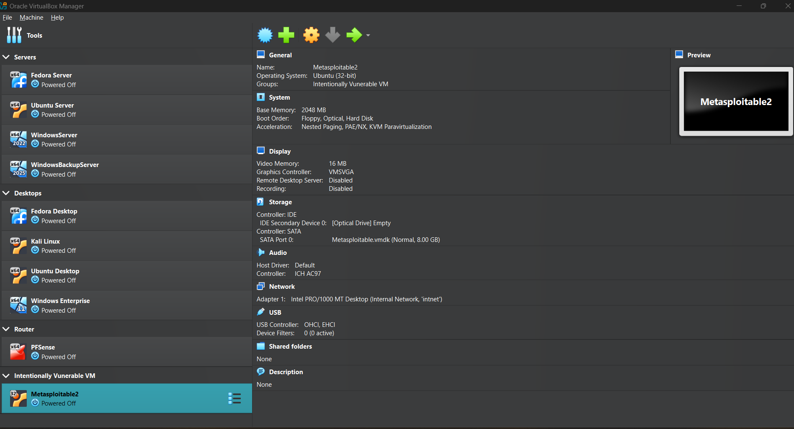
Virtual Network Configuration:
- NAT + Internal Network managed by pfSense (192.168.7.0/27)
- Reserved IPs: 192.168.7.11–19 (Blocked for Security)

5. Static IP Assignments & Packet Tracer Design
All VMs were assigned static IPs as documented in the Static IP Chart.csv. Network topology was designed in Cisco Packet Tracer for reference.
Packet Tracer Topology 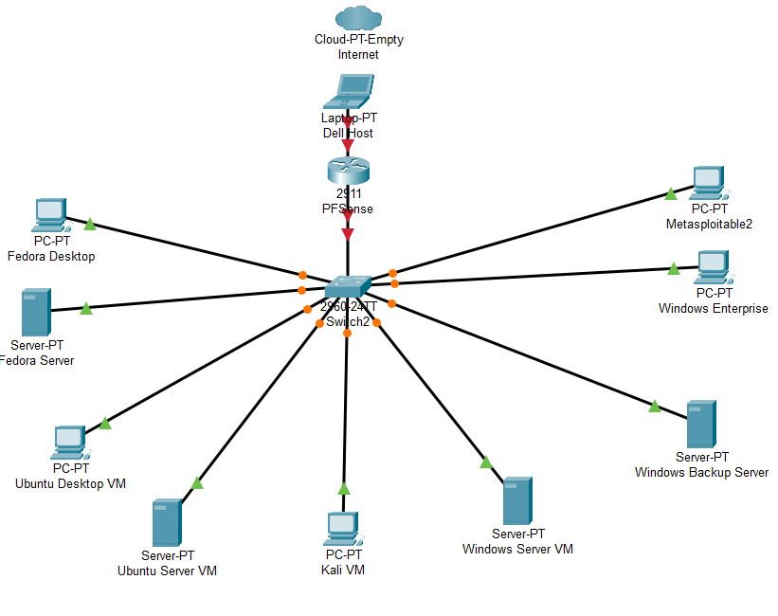

6. Windows Server 2025 Setup
Active Directory Configuration:
- Domain: JJ.Local
- User: marcanthonyjones
- Organizational Units (OUs): Admins, Standard Users
- GPO Policies: Password policies, login attempts, user rights
Get-ADUser Powershell Output 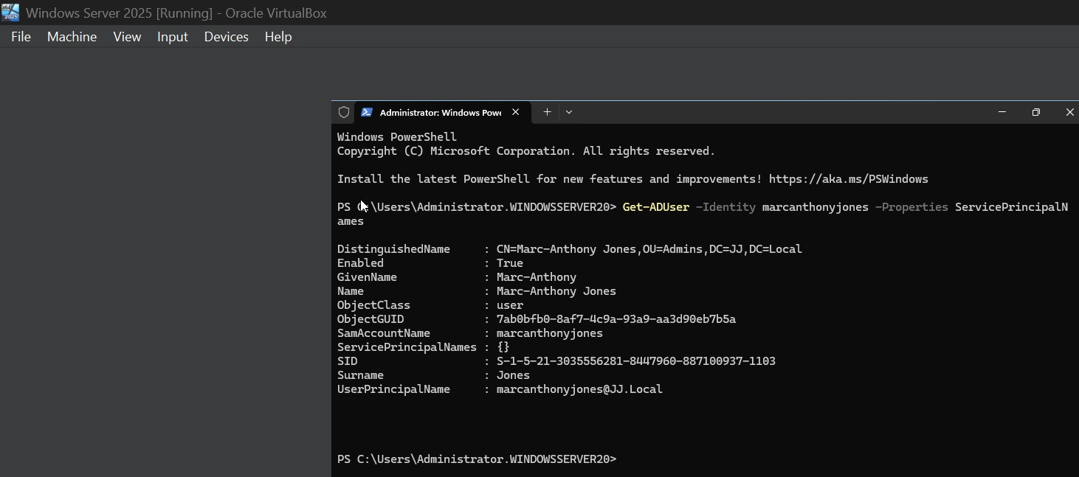

Permissions Testing: Used ICACLS and Get-Acl on SYSVOL, NTDS, System32, and Public folders.

ICACLS Scan.jpg and SYSVOL Permissions
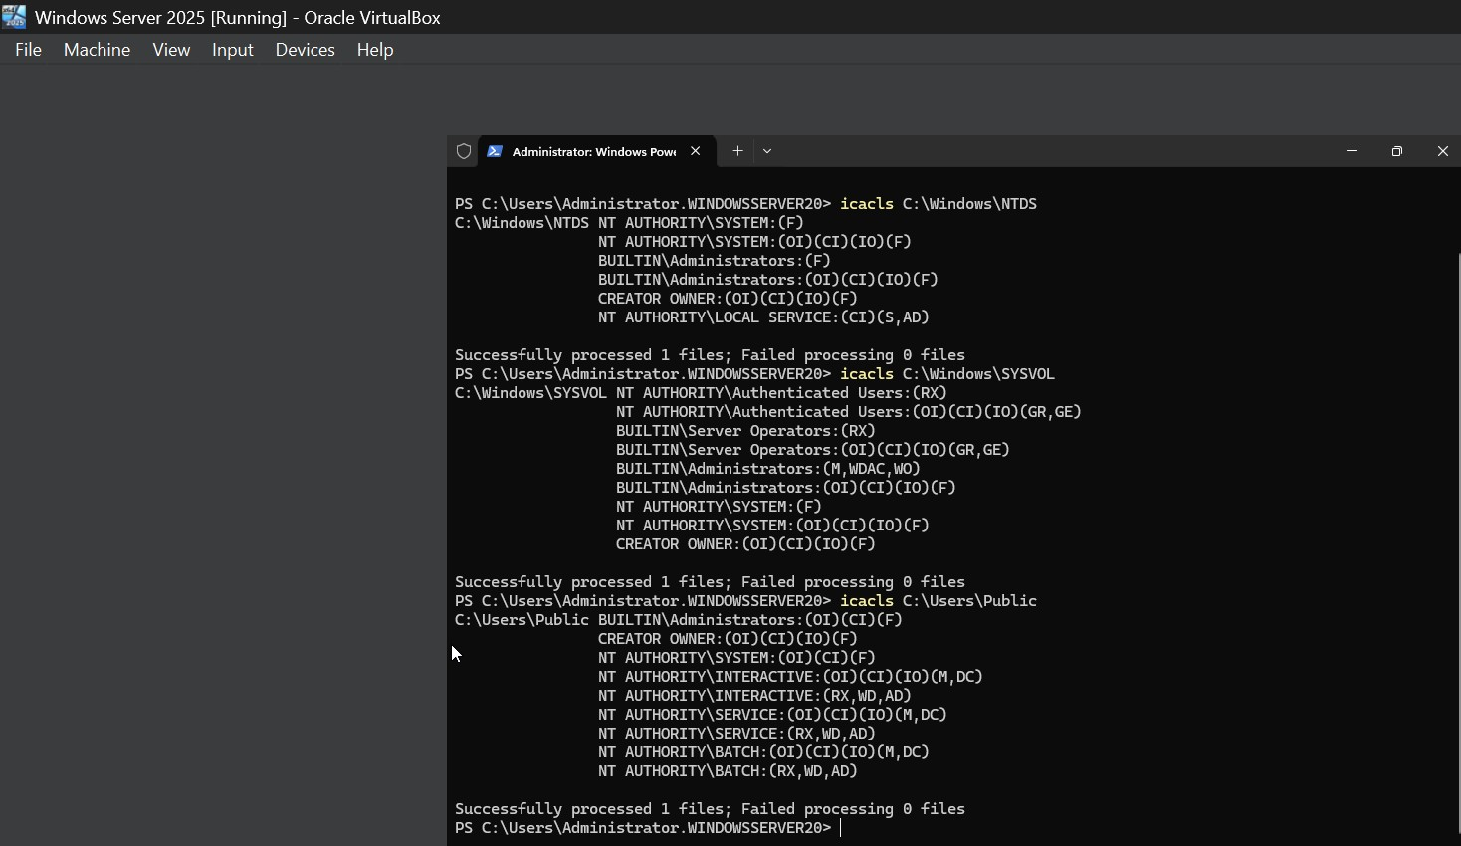
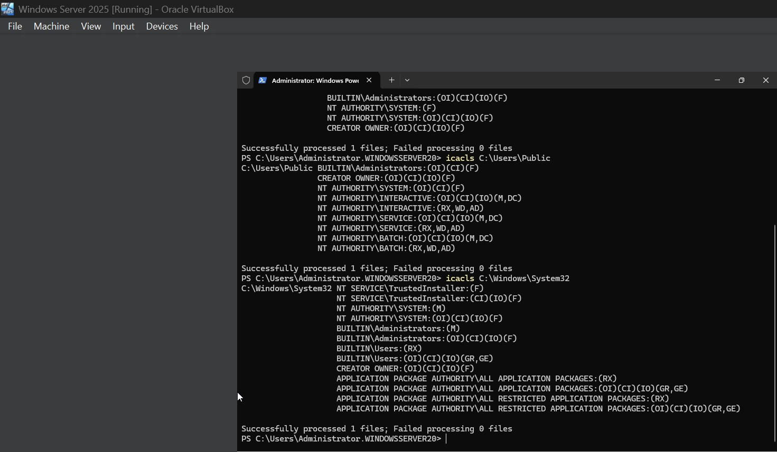
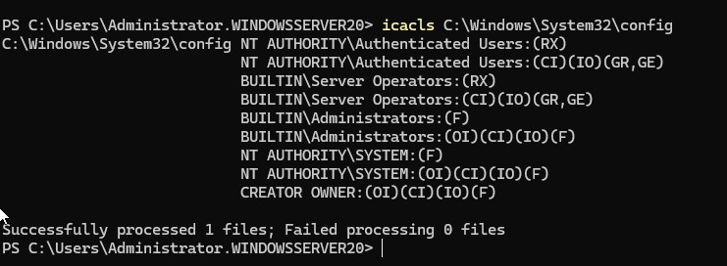
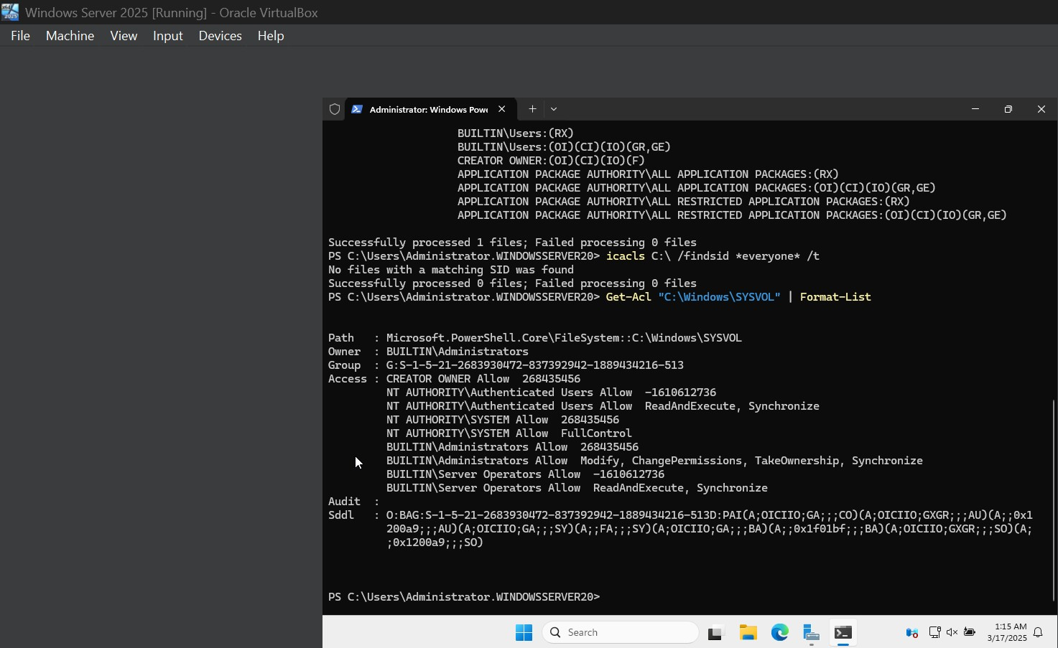

Event Log Audits:
- Detected Event IDs 4624 (Logon), 4625 (Failed Login), 4688 (New Process) [Insert Screenshot: Event Viewer - Security Logs]
Web Server Deployment:
- XAMPP with Apache, MySQL
- Directory: C:\xampp\htdocs\MyWebsite
XAMPP Web Files 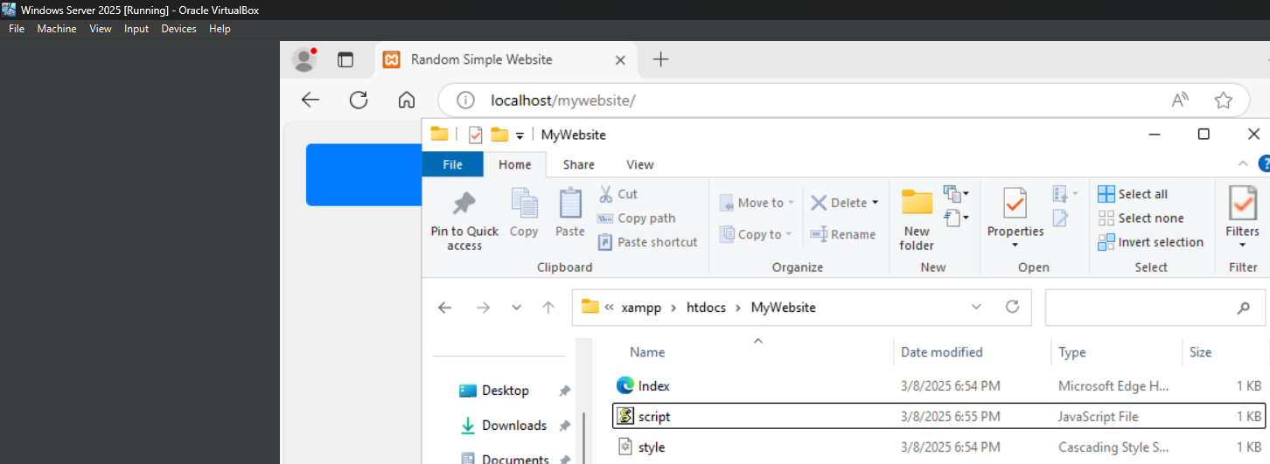
XAMPP Web Server 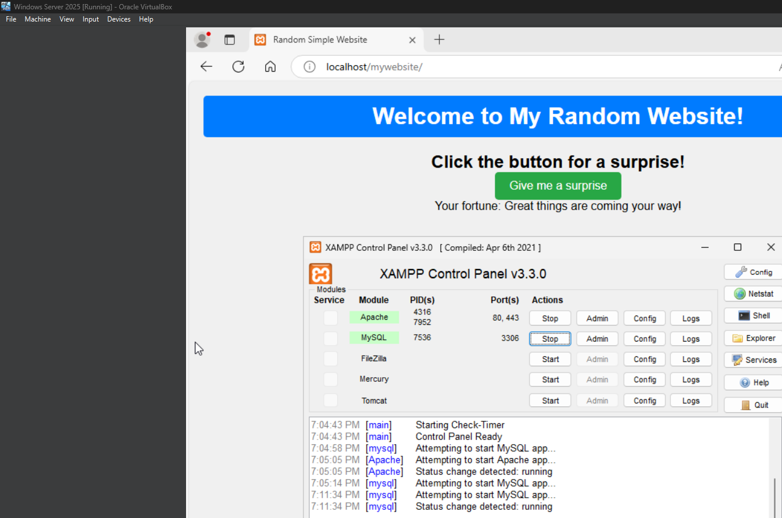

7. pfSense Firewall Configuration
- Interface: LAN (192.168.7.1)
- IDS/IPS: Suricata
- Firewall Rules: DNS, HTTP, ICMP, Blocked 192.168.7.10–14
- VPN: OpenVPN tested with weak passwords (brute-force via Hydra) [Insert Screenshot: Nikto Scan on pfSense]
MAC spoofing attempts failed (verified MAC filtering enforcement).
MACChanger Error 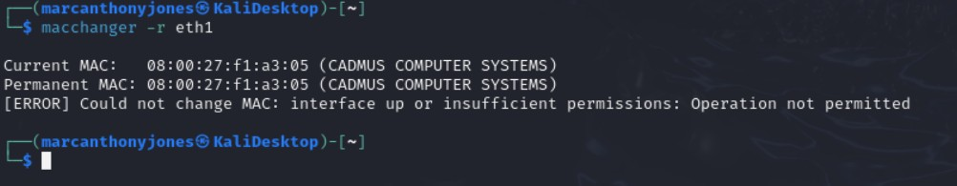

8. Linux (Ubuntu & Kali) Configuration
Ubuntu Samba Server:
- Shared directory: /srv/samba/shared
- User: smbuser
- Group: smbgroup
Samba Server Configuration File 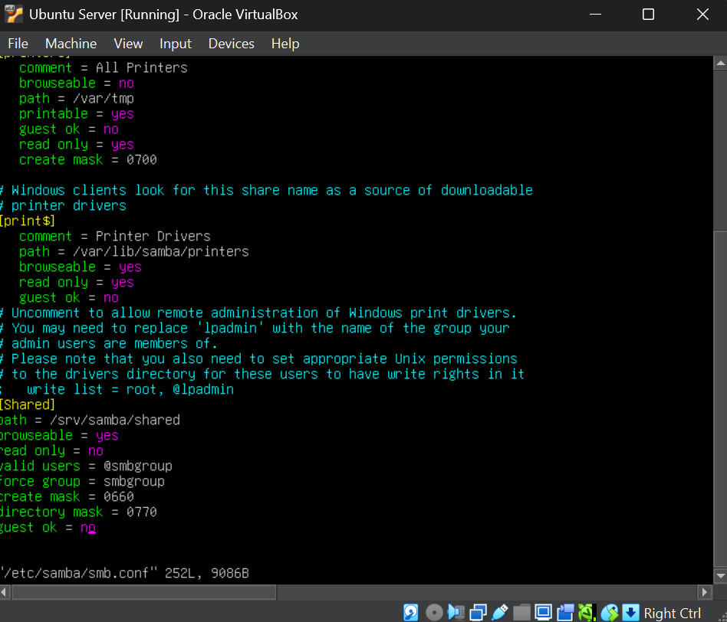
Samba Server Permission Configurations 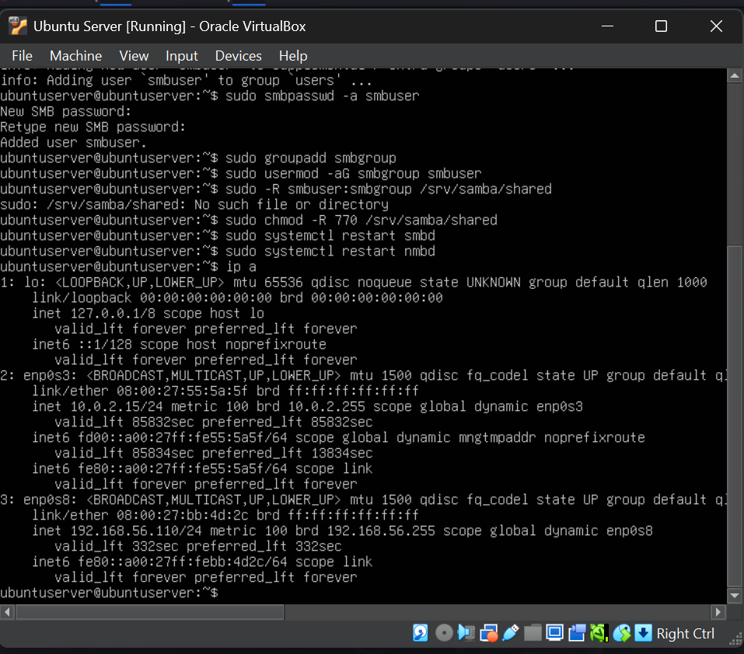

Kali Linux:
- Penetration Testing tools used: CrackMapExec, smbclient, GetUserSPNs.py CrackMapExec Scan Windows Server From Kali Linux 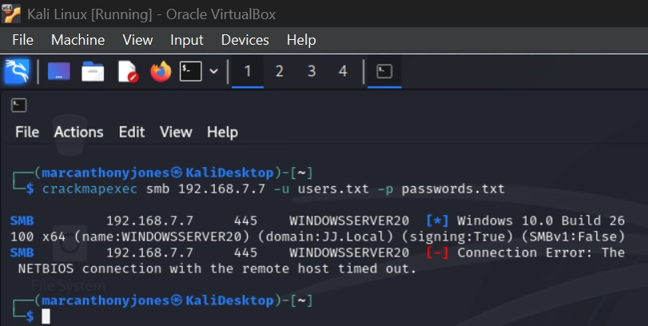

SSH Access: Kali used SSH to access Windows via OpenSSH
SSH Kali-To-Windows 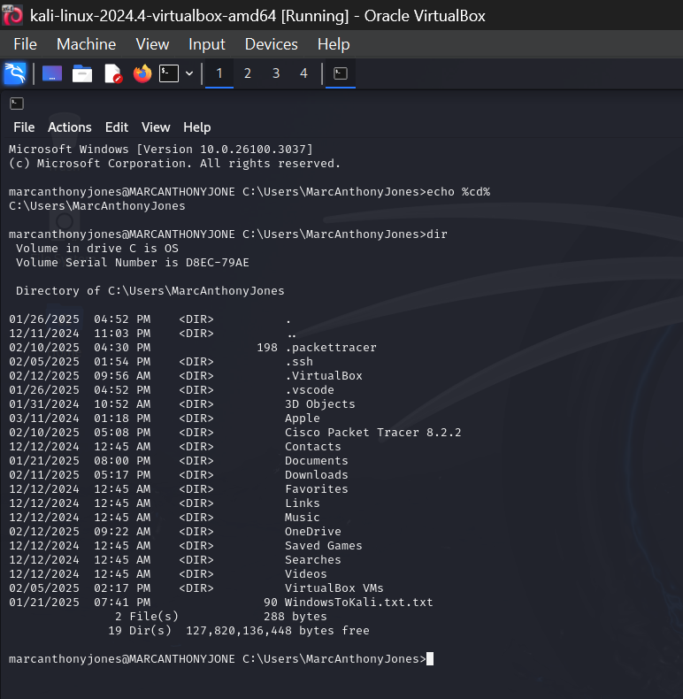

9. Penetration Testing Procedures & Results
- Weak AD password policies detected
- SMB enumeration successful
- Failed Kerberoasting due to DC rejection
- Successful Nikto scan of pfSense
- MAC address spoofing attempt blocked
See full report: Penetration Test Report.docx

10. Security Policy Highlights
From JJ’s Computer Solutions Network Security Policy.docx
- Passwords: 12+ chars, complexity enforced
- GPOs restrict admin tools, disable default Admin
- pfSense filters unused IPs and ports
- Daily Windows Server backups
- MAC filtering + Suricata IDS for detection

11. Observations, Lessons, and Next Steps
- Firewall rules were initially disabled (now active)
- Static IP enforcement was successful
- MFA is now required for admin and remote logins
- Samba shares functional but require stronger masking
- Windows web server functional under localhost only
- Rogue devices blocked successfully
Future To-Do:
- VLAN segmentation for department isolation
- Automate log collection from pfSense to Splunk
- Secure MySQL/XAMPP with stronger configs
12. Network Topology Overview (Packet Tracer)
The accompanying Cisco Packet Tracer file titled Small VM Network After PFSense Implementation.pkt visually represents the logical layout of the Small VM Network. It includes the following:
- pfSense firewall connected as the central routing node
- Segregated client and server nodes (Windows Server, Ubuntu Server, Kali, etc.)
- Static IP assignments and their mapped MAC addresses
- Visual indication of blocked IP segments for security monitoring
- Future expansion zones reserved for Fedora, Metasploitable2, and Windows Enterprise
This visual map can be opened in Cisco Packet Tracer and used for simulation, IP planning, and instructional reference.

12. Appendices
- Static IP Chart (CSV)
- Packet Tracer Topology File (.pkt)
- Full Penetration Test Report
- Full Security Policy

End of Lab Manual

